ROCKVILLE
High School Schools
Christine Fortier
Administrative Assistant
(860) 870-6050 ext. 4022
Christine.Fortier@vernonct.org

Jeff Farrell
Athletic Director
(860) 870-6050 ext. 4023
Jeffrey.Farrell@vernonct.org

athletic department
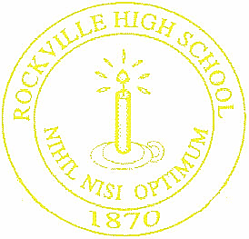

TRAVEL RELEASE FORM

DATE: ___________________

This is to certify that ___________________________________________ will be transported
(student’s name)

by me to/from/both the _____________________________________________ contest on
(circle one) (sport)

_____________________________ to be held at ________________________________.
(date) (location)

The reason for not traveling with the team is _____________________________________________

________________________________________________________________________________.

I understand that Rockville High School athletic policy requires all athletes to ride the designated
school transportation to and from all athletic events not held on the school’s designated home facility
and that a departure from this policy releases the Vernon Public Schools from any liability for any
adverse results that may occur.

I agree to release the Vernon Public Schools and its employees and officers from all liability with
reference to the above stated transportation request.

This form must be on file in the athletic office prior to dismissal of school on the day of the contest.

___________________________________________
(Parent/Guardian’s Signature)

APPROVED – NOT APROVED ____________________________________________
(Athletic Director/Administrative Assistant’s Signature)

